Sustainability of Neighbourhood Renewal funded community organisations

Background: In June 2003 using the Noble Multiple Deprivation Measure the most deprived 10% of wards across this jurisdiction were identified and the framework for the Neighbourhood Renewal Programme was established.

The Neighbourhood Renewal Programme was created to reduce the social and economic inequalities which characterise the most deprived areas. It did so by making a long-term commitment to communities to work in partnership with them to identify and prioritise needs and co-ordinate interventions designed to address the underlying causes of poverty.

In order to operationalise the Neighbourhood Renewal Programme, Neighbourhood Renewal Partnerships were established. These partnerships are made up of representative of local community interests together with appropriate Government Departments, public sector agencies, private sector interest and local elected representatives.

Context: The Neighbourhood Renewal Partnership Forum is a non-constituted collective of organisations currently delivering services regionally through thirty six Neighbourhood Renewal Partnerships funded primarily by the Department for Communities. The initial purpose of the forum was to provide a collaborative framework to work together with the Department for Communities People and Place Review Team to ensure their lived experience could be best utilised to support the NI Executive deliver against its Programme for Government in the 10% most deprived areas post April 2025.

During the course of the last eighteen months the benefits of a collaborative forum have become evident, most notably the future sustainability of the sector, particularly those Neighbourhood Renewal funded organisations delivering services in the areas experiencing multiple deprivation was identified as a serious risk.

In addition to the delivery of the People and Place/neighbourhood renewal strategy in the most deprived communities our locally place based community organisations play a critical role in the delivery of other government policies and services including work with children and young people; childcare; women’s groups; education, training and employability; health projects; community safety; advice and welfare services; good relations and interfaces; physical and environmental regeneration and much more.

A key element of our success is that we are place based community organisations located within the community we serve. This proximity allows us to identify and respond to both existing and emerging needs. The importance of place based community organisations in the delivery of statutory policy was most noticeably highlighted during the peak of Covid 19 emergency when place based community organisations where the front line of the governments successful delivery of goods and services to those most in need. In December 2021 the Department stated that it “acknowledges the vital role that the Community Sector plays in providing critical services within our communities”.

This acknowledgement of the benefits of respectful collaborative and sustainable partnership between statutory providers and place based community organisation is welcomed however the rhetoric rings hollow when the need for parity in the terms and conditions of staff working in both sectors remains absent.

The disparity in approach to the priority given to the terms and conditions of statutory colleague’s in isolation from the terms and conditions of community practitioners has fueled a belief in the community sector that its role is not valued as a genuine partner to the public sector but rather is considered as a convenient, less expensive outsourced delivery mechanism.

Although we remain committed to continuing to work in respectful, equal, collaborative and sustainable partnerships with policy makers, the absence of a genuine commitment by the Department to address this inequality may jeopardise the possibility of future best practice collaborative working, as in the absence of a community workforce strategy the sectors sustainability is a relevant live risk.

Current Workforce Analysis: In the absence of an industry regulated pay and conditions framework most community organisations adopt the National Joint Council (NJC) salary scales and terms and conditions. Each year the Northern Ireland Council for Voluntary Action (NICVA) provides and update on these scales. Figure 1 provides a comparison model for the three most common roles supported directly through Neighbourhood Renewal Funding.

The initial disparity began in 2010 when a pay freeze was introduced in line with the austerity agenda of the Tory government. This pay freeze ended in 2013 when NJC scales rose 1%, however the then Department for Social Development maintained the wage freeze for organisations which they funded. After 10 years of austerity the Department for Communities realised the injustice of this approach and in December 2021 a 2% consolidated and a 7% non-consolidated pay increase was provided by the Department. In the financial year 2022/23 there was a further 2% consolidated increase and also a non-consolidated £1,925 payment (minus Employers National Insurance Contributions). However in the current financial year that has been no wage increase.

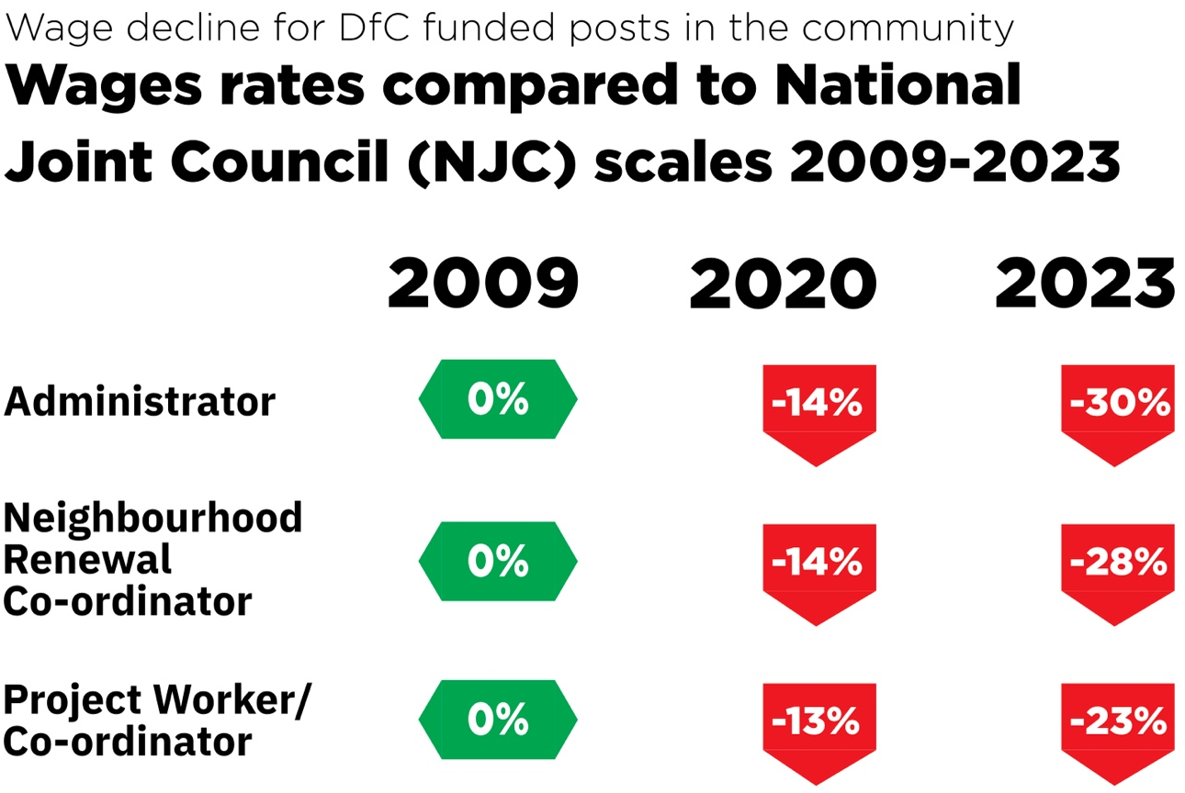
Figure 1: Example of neighbourhood renewal posts and NJC scales

The analysis in Figure 1 above demonstrates that the gulf between NJC scales and what is awarded is increasing dramatically with administrator’s salaries now 30% below NJC scales; Neighbourhood Renewal Co-ordinators now 28% below NJC; and Project Co-ordinators are 23% below.

As demonstrated by the comparison the current funding position for staff in community organisations directly funded to delivering the People & Place strategy is no longer sustainable, particularly in the current economic landscape.

The issue of pay and conditions is not the primary factor in drawing people to work in the most deprived communities. However, the decline in wages relative to other funders means that it is difficult to recruit and sustain key posts within community organisations.

The Cost of Living crisis has placed a huge challenge on staff who while committed to working in community organisations has pushed their wages to below the minimum acceptable levels required to sustainable them and their families.

The current NJC pay claim is for a 10% increase or a £3,000 across the board wage increase across all NJC pay scales. Therefore, if we do nothing the average decline with be -29%. Figure 2 shows the dramatic decline in the relevance of community salaries funded by the Department.

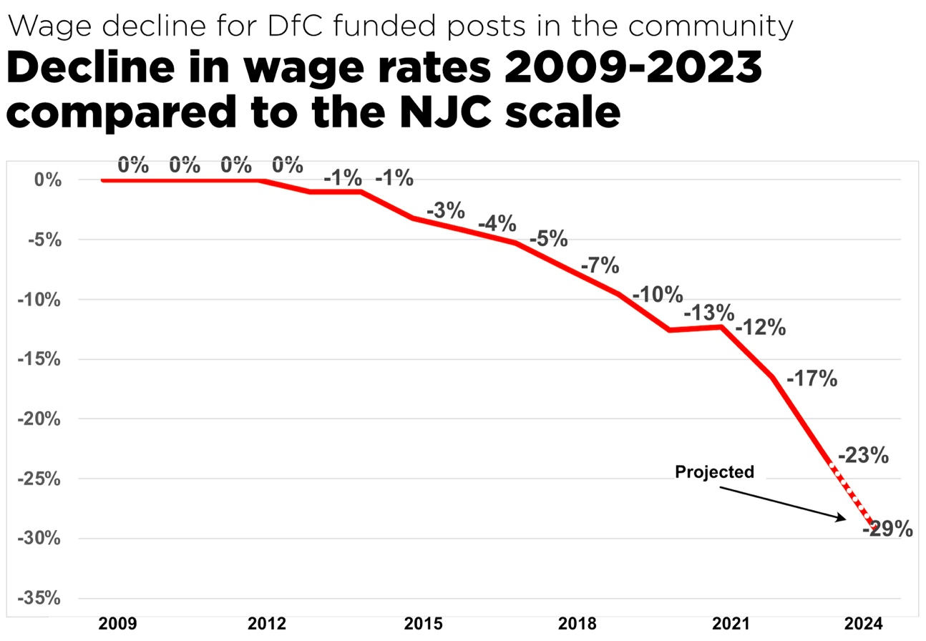
Figure 2: Wage declines for DfC funded posts 2009-2023

In an increasing number of cases management committees are subsidising staff salaries from reserves. This suggests that the Department of Communities no longer adheres or values the concept of Full Cost Recovery for their community partners.

We also have an unwelcome development within community organisations delivering neighbourhood renewal when in some cases managers are on lower wages than the staff they manage. This anomaly has been created by the manager being funded through the Department for Communities and other staff funder by another Department or another funder.

In 2021 the Department said that it was “determined to ensure that we as funders become and exemplar of a fair funding government organisation” the workforce analysis undertaken amongst our Forum members identifies the reality as falling far short of the aspiration as stated.

The Proposal : To address this inequality the Department to support the commissioning of an independent benchmarking study into the pay and conditions of those working for community groups funded by the Department for Communities. It is our understanding that such an exercise was commissioned by Minister Hargey when in post therefore it may be that the findings form that as yet unpublished report need only be reviewed and updated.

However, in recognising that the complexity of the development and implementation of the necessary comprehensive, fair and equitable new approach to how essential community partners are funded to ensure parity between their staffs terms and condition and that of their statutory colleagues we are proposing the following three short term interim options.

Option | Proposal | -/+ Impact of this option
Option 1 | Provide a £1,925 consolidated across the board increase to all staff. This is amount agreed by the National Joint Council on 1st November 2023. | This will not bridge the gap that has arisen between the wages of neighbourhood renewal staff and the NJC scale. This would reduce the disparity of neighbourhood renewal wages in comparison to NJC to an average of 17%.
Option 2 | Provide a £3,850 consolidated across the board increase to all staff. This amount was agreed in November 2022 and 2023 by the National Join Council. | This would demonstrate a commitment from the Department for Communities to make a real effort to address a problem that has evolved over a decade or more and would have an impact.
Option 3 | Provide a 5% consolidated increase and £1,500 non-consolidated payment in line with the increase agreed by civil servants. | This is an attractive option, however, this would impact more positively for the better paid large voluntaries than lower paid neighbourhood renewal staff e.g. 5% for an administrator on £21k is £1,050 – whereas 5% for a project manager with a large voluntary on £48,000 will receive £2,400

Real Living Wage: Finally, all staff working on neighbourhood renewal projects should receive at least the Real Living Wage, currently £12 per hour. This line with the then Minister of Finance Conor Murphy’s stated in November 2021: “The Executive is committed to paying civil servants at least the Living Wage. This commitment will also apply to new contracts for people who work in civil service buildings which will impact on staff providing security, catering, and cleaning services.” This agreement should extend to those staff working for community sector organisations delivery government programmes.

