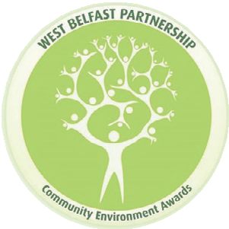

Introduction

WEST BELFAST PARTNERSHIP COMMUNITY ENVIRONMENT AWARDS 2026

APPLICATION FORM



Now in its 23rd year, the Community Environment Awards celebrate the work of local people in west Belfast who improve and enhance the quality of the environment in which they live, work or are educated. The Awards are also a vehicle through which West Belfast Partnership and sponsors can actively promote environmental regeneration efforts across West Belfast. Our aim is to encourage the community, businesses and public agencies to take ownership and responsibility for protecting the environment, to make west Belfast a better place to live, work and play and to reward them in their efforts when they do so.

Our Awards
The West Belfast Partnership Community Environment Awards have a number of Award categories: -

- West Belfast Partnership Public Art Award – Open to individuals, groups or businesses who have been involved in public art projects which have improved the physical landscape of west Belfast.
- Ark Education Award – Open to all schools and nurseries who have been involved in projects which have raised environmental awareness and improved the environment.
- West Belfast Partnership Environment Award – Open to individuals, community groups or businesses in west Belfast who have been involved in projects of significant environmental endeavour and achievement.
- Bryson Recycling Award - Open to individuals, community groups or businesses who demonstrate a commitment to recycling or reuse through a project or activity.
- Active Communities Network Community Award – open to residents or community groups who use environmental projects to improve and enhance their neighbourhood.

APPLICATION

Contact Person:

Organisation/Group/Individual:

Telephone Number:

E-mail Address:

Project Name:

BT12 7FP
Project address:

Please note:
You must have the necessary authorisation from your organisation/group to enter your project in the awards. You are encouraged to send any photos/videos of your project with your application to lianne@wbpb.org. Please ensure if you are sending images which include children, you have the relevant consent.

Any images or media forwarded may be used for promotional activities associated with the Awards.
In entering the awards you must be willing to accommodate a judging panel visit. At this visit you will have the opportunity to showcase and explain your project.

(Judging panel will be visiting projects on 29 and 30 April 2026)

In entering the awards, you agree to accept the decision of the Judging Panel and to participate in an awards presentation.

Tell us a little bit about your project and why you wish it to be considered for an award? You may want to outline the aims of the project, who it has involved, and the benefits it has achieved. (Expand the box or include additional sheets to include more text as necessary). Please send any photos/videos of your project.

APPLICATION

DECLARATION
The new General Data Protection Regulation (GDPR), which came into effect on 25 May 2018, requires us to have your written consent to hold your personal information within our records. Your information will be used by WBPB to process your application and to provide you with follow-up information. Your information will be retained by WBPB for a six-month period.

I consent to WBPB holding details provided in this form.

I consent to receiving e-mails/marketing materials from WBPB.

Please return completed application forms by 12noon on Friday 17 April 2026
via e-mail to:
Lianne Carlile
lianne@wbpb.org
Tel: 028 9080 9202

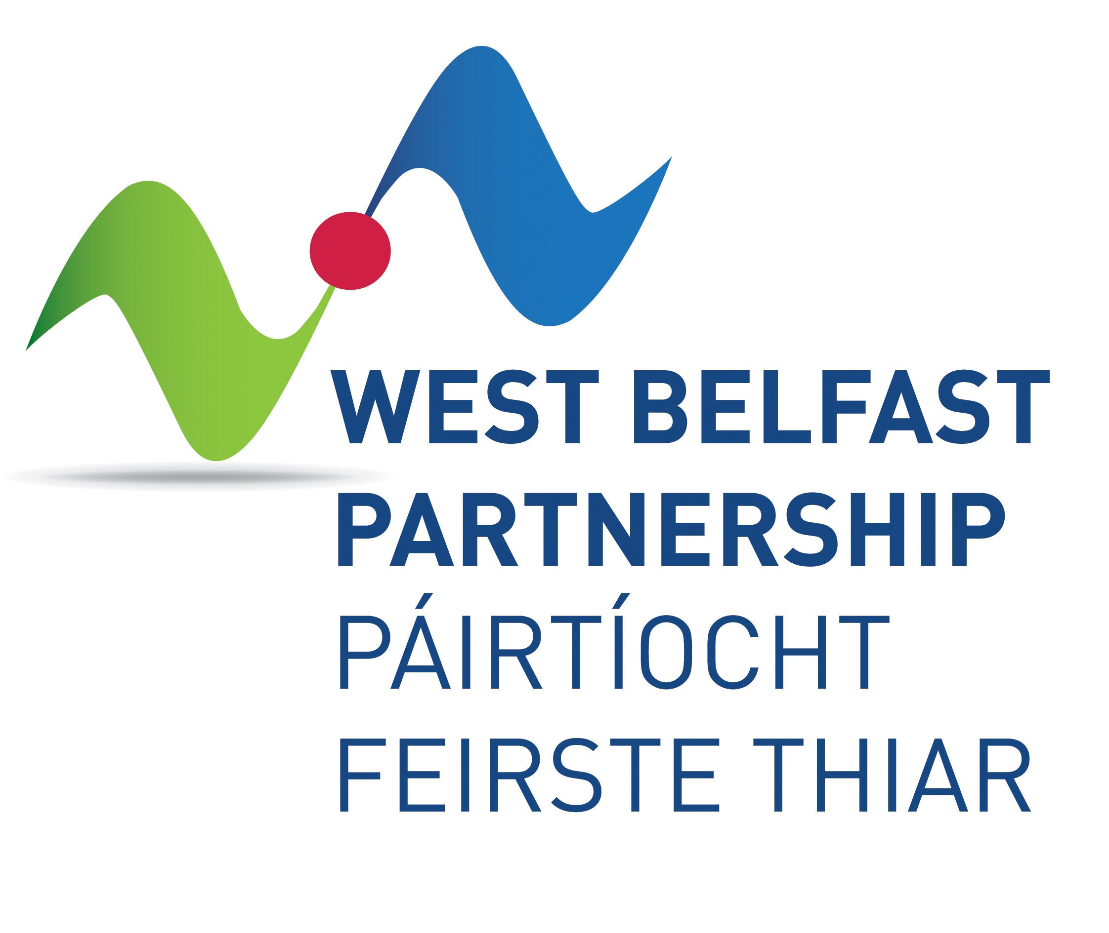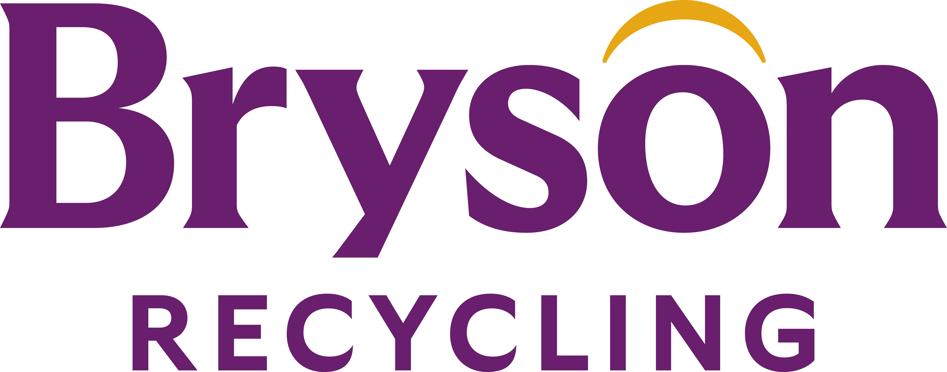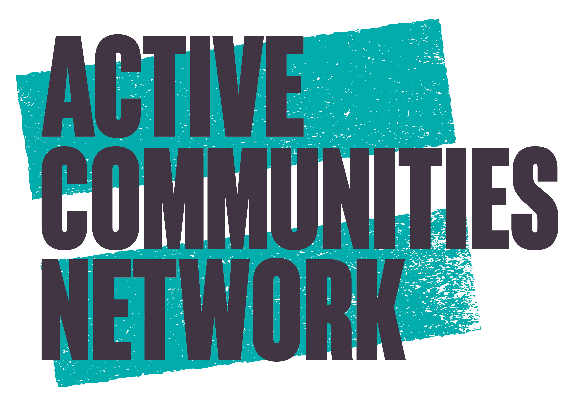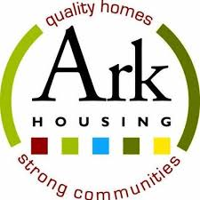

We will recognise the work of local people at our Community Environment Awards Ceremony on Tuesday 12 May 2026 at 12noon in Roddy McCorley Heritage Centre, 203 Glen Road, Belfast, BT11 8BU (refreshments provided)

